From BI to big data

Understand concepts, processing environments, and architectures required to create new business intelligence from big data

From BI to big data

Contents

From BI to big data 2
Introduction 3
Assessment 3
What is data engineering? 4
Required infrastructure technologies 4
Activity 5
Comparing processing architectures 10
Processing big data 13
How did big data happen? 13
Challenges BI faced as big data evolved 15
Activity 16
Solutions for BI with big data 17
Activity 19
Hadoop technology 23
Understanding HDFS 23
Understanding MapReduce 25
Word counting 26
Activity 27
YARN 29
Resourcing and scheduling Hadoop jobs 29
Hadoop operations 30
Usual steps to process data with Hadoop MapReduce 30
Starting a Hadoop cluster 30
Activity 31
Hadoop commands 32
Basic Commands to use with Hadoop clusters 32
Activity 33

Introduction

The evolution of data science and data engineering have drastically changed how businesses operate and make decisions. From the early days of business intelligence (BI), where structured data was processed for insights, to the explosion of big data, which brought unprecedented volume, variety, and velocity of information, organizations have had to adapt their tools, architectures, and practices to stay competitive.

This workbook helps you explore the journey from BI to big data, highlighting the challenges that traditional BI systems faced and the innovative solutions that emerged with big data technologies.

Along the way, you'll gain an understanding of key concepts, including about data engineering, HDFS, MapReduce, and the foundational steps of working with distributed processing.

By the end of this workbook, you will have the knowledge to:

- Compare traditional and modern data processing architectures.
- Understand the core principles of big data technologies like HDFS and MapReduce.
- Apply basic commands and steps to process data using Hadoop.

This course combines theoretical insights with practical activities, helping you grasp issues related to processing and managing data effectively in a big data ecosystem.

Assessment

Assessment of this module is achieved by successful submission of:

- Completed workbook

- This workbook needs to be completed accurately and submitted by due date
- All answers provided can be defended during a professional discussion
- Project

  - There is a 3-phase project submitted during Sprint 5
  - All 3 phases are Bash scripts
  - Phase 2 can be completed after this workbook

What is data engineering?

Requires a collection of skillsets and technologies and focused to enable seamless, reliable, and scalable access to high-quality data for analysis, decision-making, and machine learning applications.
The primary goal is called business intelligence (BI).

Why we do it?

- It facilitates data-driven decision making.
Ensures stakeholders have timely, accurate, and well-organized data to support strategic insights and business decisions.
- It minimizes bias, enhances accuracy, and enables more informed, strategic choices by leveraging objective insights from data.

What is being engineered?

- The process of designing, building, and maintaining the infrastructure and systems that enable data collection, storage, and analysis at scale.
- Core components include data pipelines, data lakes, data warehouses, and real-time processing systems.
Is this Data Science?

- Data Science and Data Scientists produce actionable insights in new ways and develop predictive models for decision-making
- Data Engineering ensures the availability of reliable, high-quality data for use by data scientists and analysts

Required infrastructure technologies

- Leveraging cloud services (AWS, Azure, GCP) or on-premises solutions to create scalable and cost-effective data ecosystems.
- Organising raw and processed data in scalable storage systems such as HDFS, AWS S3, or Snowflake.
- Utilizing modern tools like:
  - dbt for analytics engineering, it helps transform raw data into clean, structured data sets for analysis.
  - Apache Beam for unified processing, a data processing framework for batch and stream data. It's a tool for creating unified pipelines.
  - Terraform for infrastructure-as-code, it’s used to manage and automate cloud resources for data platforms.

Processing architectures

- Balancing real-time streaming tools (e.g., Apache Kafka, Apache Flink) with batch-oriented systems like Hadoop for processing large datasets.
- Ingesting at scale lots of data from diverse sources (e.g., APIs, logs, databases) into a centralized system using tools like Kafka or Flume.
- Cleaning, enriching, and transforming raw data into usable formats.
- Using ETL/ELT tools like:
  - Apache Spark
  - Talend
  - Airflow

Access controls and compliance

- Implementing access controls, data masking, and compliance with regulations like GDPR and HIPAA to ensure data privacy and integrity.
- Working closely with data scientists, analysts, and business teams to ensure that data solutions meet organizational objectives and provide actionable insights.
- Data marts enable secure, role-specific access to data while maintaining compliance and fostering a data-driven culture tailored to the organization's needs.

Activity

Explain these terms:

What is Data Science?
The act of extracting actionable insights from data
Data cleaning
Removing and adjusting malformed or unusable data for future analysis/automation
Data collection
Extracting quantitative and qualitative logs of events for analysis
Data custodian
An invididual whos job is to ensure that data entered is correct and sorted for analysis and automation
Data-driven decision making
Making educated decisions based on trends and analyses found within data
Data integrity
Ensuring that data is valid and not tampered with from its origins
Data integration
The process where data from different sources and formats are collated into a single database for analysis
What is an Exabyte?

10^18 bytes, an inordinate amount of data

Describe the processes:

What are the 2 main types of data ingestion?

Batch and stream processing, stream is immediate while batch is in scheduled segments
What are the 4 main considerations when ingesting data?

Defining data sources, scalability, storage amounts and data validation
Compare 3 ETL/ELT tools and find out which of FDM clients use them

Research online how you could create a data mart in Azure.

- Try using a search engine to discover web pages from vendors like AWS and Microsoft on how to create solutions they recommend.
- Also try using Copilot for how it can be done.

Comparing processing architectures

Host-based architecture

- Single machine processing for smaller applications or low-complexity environments unless using a mainframe
- Typically, data processing and storage happen on a single machine (e.g., a mainframe or powerful server)
- Supports both batch and real-time data processing
- Limited ability to scale up by increase speed or numbers of CPUs or cores in CPUs
- High control over all resources in the system including physical
- Single point of failure if the host goes down
- UNIX OS from smallest processor to largest mainframe
- Mainframes still dominate industries where reliability and scale are critical

Client/server architecture

- LANs for sharing resources like databases, file systems, printers, internet connections
- In client/server architecture, the client (user interface or application) sends requests to the server (the system that processes these requests, stores data, and returns results)
- Easier to scale by adding more servers
- Requires more infrastructure management, especially in larger systems
- Security and access control need to be carefully managed
- UNIX and Windows Servers
- Essential for home and office
- You usually connect via WiFi but servers usually connect via cable

Data warehouse architecture

- Analytics and Reporting for historical data analysis, typically for business intelligence (BI)
- A data warehouse is a centralised repository designed for analytics and reporting
- It stores large volumes of structured data collected from multiple sources, and it’s optimised for fast querying and reporting rather than transaction processing
- Typically contains historical data that’s cleaned, transformed, and aggregated for analysis
- Data is stored in a structured format, optimised for fast querying (e.g., columnar format, relational)
- High initial setup and maintenance cost
- Not well-suited for unstructured data
- RDBMS (usually Oracle) running on UNIX, mainframes, and specialised data warehousing appliances
- Originally developed as traditional on-premises systems now migrated to cloud-native, distributed architectures that offer scalability and flexibility

Cloud architecture

- Scalable, on-demand infrastructure for flexible, distributed computing and storage, especially suited for modern data workflows
- Highly scalable and elastic, meaning resources can grow or shrink based on demand
- Typically includes integrated services for storage, compute, databases, and analytics
- Flexible pay-as-you-go pricing instead of purchasing or leasing hardware (OpEx vs CapEx)
- Security concerns, as data is hosted off-premises or outside national boarders
- Data transfer costs can be high for large datasets
- Dependency on cloud service providers for uptime and service reliability
- Leads innovation with scalability and integration with modern technologies

Data lake architecture

- Big data storage and cloud flexibility for unstructured, semi-structured, and structured data
- A data lake is a centralised repository designed to store data in its native format from a variety of sources and is optimised for storing large datasets
- Supports both batch and real-time data processing
- Often associated with big data technologies like Hadoop and Spark
- Flexible for future use cases (e.g., AI/ML, advanced analytics)
- Complexity in data governance and quality
- Lack of data structure can make querying difficult
- Requires robust metadata management to ensure efficient data retrieval
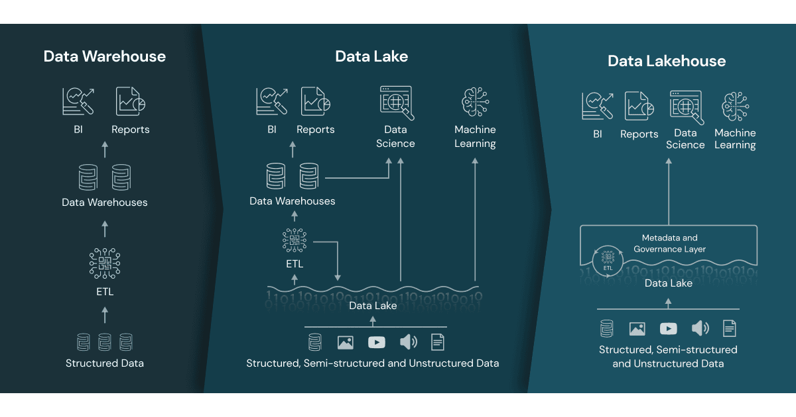
Source: https://www.databricks.com/blog/2020/01/30/what-is-a-data-lakehouse.html

What processing architectures do FDM clients use?
Document anything that you can use in an interview.

- Mainframes

- Client/Server

- Data warehouse

- Cloud

- Data lakes

Processing big data

How did big data happen?

The internet and connectivity

- Global internet adoption: The rapid expansion of the internet, especially after the 1990s, has made data creation and sharing ubiquitous
- Social media platforms: Platforms like Facebook, Twitter, and YouTube have become massive repositories of user-generated content
- E-commerce growth: Online shopping platforms collect vast amounts of data on transactions, user behaviour, and preferences
- Shift to digital records: Industries such as healthcare, finance, and government have transitioned from paper-based systems to digital recordkeeping
- Media digitisation: Books, music, videos, and photographs have moved from physical formats to digital
- Streaming services: Platforms like Netflix and Spotify generate massive data on user preferences and viewing/listening habits
- Online collaboration: Tools like Zoom, Slack, and Google Drive have increased data generation through remote work and online collaboration
- Proliferation of personal devices: The widespread adoption of smartphones, tablets, and personal computers has turned billions of individuals into constant generators of digital data
- IoT and smart devices: The Internet of Things (IoT) has introduced a vast network of connected devices (e.g., sensors, smart appliances) that continuously generate data

Business and economic drivers

- Data-driven decision-making: Businesses increasingly rely on data for competitive advantage, incentivising more data collection and storage
- Advertising and personalisation: Targeted advertising models have encouraged companies to collect and analyse massive datasets on user behaviour
- Declining costs of storage: The cost per gigabyte of storage has decreased dramatically, making it feasible to store vast amounts of data
- Unstructured data growth: Advances in tools for analysing images, text, audio, and video have made it possible to extract value from previously untapped sources
- Social media and communication: Texts, tweets, blogs, and reviews now contribute significant unstructured data

Improvements in data processing technologies

- Cloud computing: Cloud storage solutions have provided scalable and affordable storage options, enabling companies to store and access large datasets easily
- Big data frameworks: Tools like Hadoop and Apache Spark have made it easier to process and analyse large datasets
- Increased computing power: Advances in CPUs, GPUs, and distributed computing have allowed faster data processing
- AI and machine learning: These technologies have unlocked the potential to extract insights from previously unstructured data

In 1995 AOL had less than 60 million users
In 2025 google has less than 99,000 million users.

Watch this video to get some appreciation of how quickly e-commerce has grown - https://www.youtube.com/watch?v=dOJS5wbIlos
Create your own visualisation to show the difference between 60M and 99,000M

What is a tech unicorn?
Use this webpage to answer the question - https://pitchbook.com/news/articles/unicorn-startups-list-trends

.
A tech unicorn, according to PitchBook, is a privately held, venture-backed company that most recently raised funding at a valuation of $1 billion or more.
A company stops being a unicorn if:
- It is no longer venture-backed because it goes public (IPO) or is acquired, or
- Its valuation falls below $1 billion (e.g., down round or business failure).

Challenges BI faced as big data evolved

The growth of data in digital formats is driven by the convergence of technological advancements (better storage, computing, and processing), societal trends (internet and device adoption), and economic incentives (data monetization).
Together, these forces have transformed the digital landscape, making data more abundant and accessible than ever before.
Different sources discuss different V’s in big data but the underlying issues are more important:

- Volume - scalability and performance

- Traditional BI systems were designed for structured data in relational databases
- As data volumes grew, scaling these systems to process massive datasets became increasingly difficult and expensive
- BI tools relying on SQL queries over large relational databases faced slow query performance, especially for complex analytics and reporting

- Variety (structured, semi-structured, and unstructured data)

- Traditional BI systems expected data to conform to predefined schemas, making it hard to accommodate semi-structured (e.g., JSON, XML) or unstructured data (e.g., images, text, videos)
- Merging disparate data types from multiple sources (e.g., relational databases, web logs, IoT devices) posed integration challenges

- Velocity

- Traditional batch-processing BI systems were inadequate for handling fast-moving data streams generated by IoT devices, social media, and other sources
- Generating insights from high-velocity data required near-real-time processing capabilities, which existing architectures often lacked

- Variability

- Fluctuating data formats and structures increase integration complexity
- Challenges handling seasonality or contextual relevance in data

- Value - lack of value with advanced analytical capabilities

- Early BI systems were optimised for static reports and dashboards, not for advanced analytics like machine learning or predictive modelling
- Handling text, images, or audio for deeper insights (e.g., natural language processing) was outside the scope of traditional BI tools

- Veracity - data governance and quality

- Ensuring consistent data quality and governance across a more complex pipeline became harder
- Sensitive or regulated data added complexity, especially as laws like GDPR emerged later

- Visualisation

- Traditional BI tools lack capabilities for complex data presentations
- Difficulties in real-time and dynamic data visualisation

Activity

Answer questions are regarding basic Data Science knowledge and terms:

What is meant by “Big Data”?

Large quantities of data with high dimensionalities that cannot be manually analysed
What is a Data Visualisation?

PowerBI etc, ways to make large quantities of data digestible by the human eye

Solutions for BI with big data

Businesses wanting to exploit new opportunities created technologies and frameworks to achieve commercial use cases
The software created was shared under Apache License 2.0, a permissive open-source license

- Netflix: Uses Hadoop for data analytics and personalised recommendations
- LinkedIn: Analyses user activity for targeted content and network growth
- eBay: Employs Hadoop to handle massive auction-related data
- X/Twitter: Processes tweet data for sentiment analysis and trends

Goals of the Hadoop ecosystem:

- Scalable storage: Efficiently store large datasets (structured, semi-structured, and unstructured) in a distributed manner
- Cost-effective big data processing: Use commodity hardware to process massive datasets without expensive infrastructure. Commodity hardware is less expensive because of mass production like personal computer hardware
- Fault tolerance: Ensure high availability and reliability despite hardware failures
- Flexibility: Handle diverse data types and formats (logs, images, text, etc.)
- Distributed computing: Enable parallel processing across large clusters for fast analytics
- Integration: Offer a unified platform with tools for querying, scheduling, machine learning, and real-time processing
- Open source: Provide a community-driven, free-to-use platform

The result is a Hadoop cluster using inexpensive machines or virtual machines that can be scaled out to handle larger workloads, simplifying the use of the MapReduce paradigm for distributed data processing and is the base for an ecosystem of solutions that make use of this infrastructure.

Components of the Hadoop ecosystem

Use the following list to get an overview of the ecosystem, especially how there is a need for different tools for automation
More details included in ‘Hadoop ecosystem and Hive’ module
References:
https://hadoop.apache.org/
https://www.apache.org/index.html#projects-list

Some of the Apache Hadoop projects by category

Storage:
- HDFS - default
- Hbase

Processing frameworks:
- MapReduce - default
- Apache Tez
- Apache Spark

Resource management:
- YARN - default
- Mesos

Querying & data analysis:
- Apache Hive
- Apache Pig
- Presto
- Impala

Data ingestion:
- Apache Sqoop (RDBMS integration)
- Apache Flume (log data collection)

Workflow automation:
- Apache Oozie - task scheduling and orchestration within the Hadoop ecosystem
- Apache Airflow - managing workflows across diverse environments, highly versatile
- Apace Cascading - complex data workflows directly on Hadoop/Spark, high-level data engineering pipelines

Machine learning:
- Apache Mahout
- Apache Spark MLib

Activity

Answer questions are regarding basic Data Science knowledge and terms:

Why do we need distributed computing?

WE need distributed computing because modern datasets are too large and complex for a single machine to process efficiently. It enables parallel processing, fault tolerance, and horizontal scalability. This allows organisations to handle big data workloads reliably and at speed.

What is meant by the term “scalability”?

Scalability means a system’s ability to handle increasing workload or growth without breaking down or losing performance.
What problems increase when scaling out instead of up?
It introduces network latency, data consistency challenges, coordination complexity, and higher operational overhead. Distributed systems require sophisticated mechanisms to manage synchronisation, security, and failure handling.
What is “Failover” and why is it useful?
Failover is the process where a system automatically switches to a backup component when the primary component fails. If one server crashes another one immediately takes over so users don’t notice.
Briefly describe the core components of Hadoop?
Hadoop consists of HDFS for distributed storage, YARN for resource management, and MapReduce for parallel data processing. Together, these compoenents enable scalable and fault-tolerent big data processing across clusters.
What are the two main phases of distributed processing that you need to write code for using Hadoop?

- What programming languages can be used?
In hadoop distributed processing, the two main phases developers write code for the Map phase, which transforms input data into key-value pairs, and the reduce phase, which aggregates those pairs to produce final results.
What is your elevator pitch explanation for each term to quickly demonstrate that you understand this technology?

- fault tolerance
Fault tolerance is a system’s ability to continue operating even when individual components fail. In distributed systems like Hadoop, tasks are automatically reassigned and data is replicated so that hardware failures don’t interrupt processing.

- data replication in HDFS
Data replication in HDFS means each data block is stored on multiple DataNodes, typically three by default. This ensures reliability and availability — if one node fails, the system can retrieve the same data from another copy.

- data locality
Data locality refers to moving computation to where the data is stored instead of moving large amounts of data across the network. In Hadoop, processing tasks are scheduled on the same nodes that store the data blocks to improve performance and reduce network overhead.

- resource management
Resource management is the process of allocating and controlling computing resources like CPU, memory, storage, and network bandwidth to ensure tasks run efficiently and fairly without overloading the system.
Which challenge(s) has Apache Cascading broken and how?

Apache Cascading addressed the complexity and rigidity of raw MapReduce by introducing a higher-level API that allowed developers to define data processing flows rather than low-level jobs. It simplified job chaining, improved code reuse, and made distributed data pipelines easier to build, test, and maintain.
What is meant by cloud computing?

Cloud computing is the delivery of computing services — such as servers, storage, databases, networking, and software — over the internet instead of running them on your own physical machines.
Describe 3 future trends of data science or engineering?
Three major future trends in data science and engineering are increased automation through AI-powered pipelines, the shift toward real-time streaming architectures, and a growing emphasis on data governance and responsible AI. Together, these trends show that the field is becoming faster, more intelligent, and more regulated.

Apache has Oozie, Airflow, and Cascading for workflows.
Why is there more than one workflow automation project?

There is more than one workflow automation tool because they were built for different architectural needs and eras of big data. Oozie was designed specifically for Hadoop scheduling, Cascading simplifies MapReduce development, and Airflow provides modern, cross-platform orchestration. As data ecosystems evolved from Hadoop-centric to cloud-native and multi-system environments, multiple workflow tools emerged to address different layers of complexity.
Apache projects also exist for searching big data but there are other providers that might be more popular with FDM’s clients.

Find out if these vendors products can work in the ecosystem –

- Apache Lucene is the underlying library used by both Apache Solr and Elasticsearch for indexing and search functionality

- Elasticsearch is a widely used distributed search engine, often paired with Kibana for visualisation, it excels in full-text search and analytics

- Splunk is a commercial platform for searching, monitoring, and analysing machine-generated data like systems log management and analytics

Hadoop technology

Understanding HDFS

- Input splits are logical divisions of data used to parallelise processing efficiently
- The size can be configured but is typically matching the HDFS block size (128 MB)
- Each input splits is processed by a single Mapper to ensure balanced and parallel task execution
- Hadoop has a default replication factor setting that can be changed for different clusters
- The default is 3 meaning each block is stored on three different nodes for redundancy

- The NameNode maintains a map of where data is stored and replicated
- Rack awareness goal is to minimise losses for efficient recovery after a hardware or software failure affecting elements like hard disks, nodes, cables, switches, and other networking devices
- Block reports are sent to the NameNode but processed by Secondary NameNode
- This improves the NameNodes availability to support the resource manager and receive block reports

Understanding MapReduce

The 5 stages of MapReduce typically refer to the process of splitting, mapping, shuffling, reducing, and outputting data. Each phase plays a crucial role in processing large data sets efficiently:

- Splitting : The input data is divided into smaller chunks or splits to distribute
- Mapping: Each split is processed by a map function, which transforms the data into key-value pairs
- Shuffling: The key-value pairs are sorted and grouped by key
- Reducing: The grouped data is processed by a reduce function, which aggregates the values for each key
- Outputting: The final output is written to a file or database
Bespoke code is only needed for the Map and Reduce functions
The rest is done by the framework !

Common scenario for distributed processing with Hadoop

NB: the information in 2nd column is the category or key and the 4th is data to aggregate

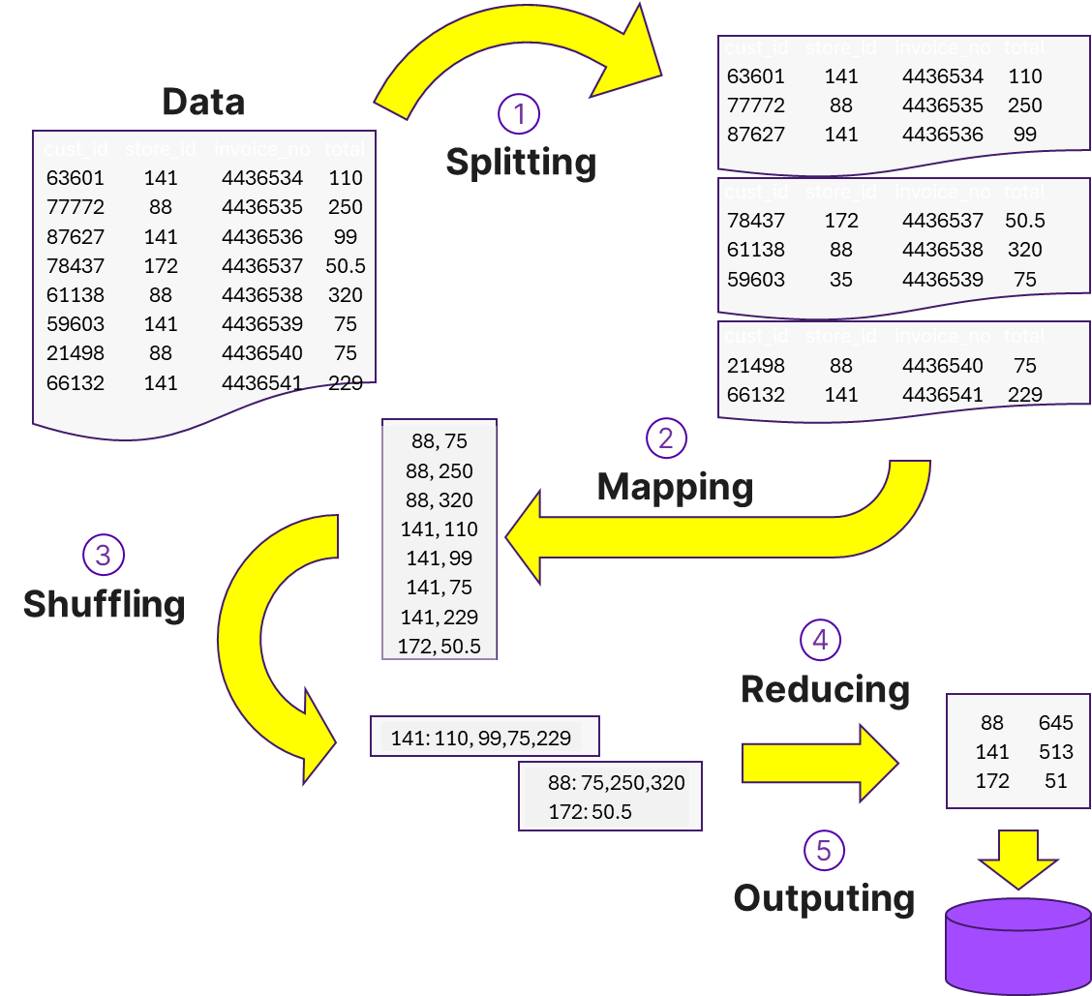

Word counting

- Working out how to process the information can be a challenge if there are no obvious numbers to aggregate
- The WordCount algorithm is considered the "Hello World!" of MapReduce to demonstrate the fundamental concepts using straightforward logic
- It also illustrates that we can add information to the source so the reducing function can arrive at an answer via aggregation of the key value pairs created

If we want to count how many times each word appears we can use the following map/reduce steps:

- Each word identified is mapped to a key value pair of the word as key and 1 as the value
- All the key, value pairs get grouped by key so the values can be aggregated, in this case added together
- The result is each word with the number of times it appears in the source

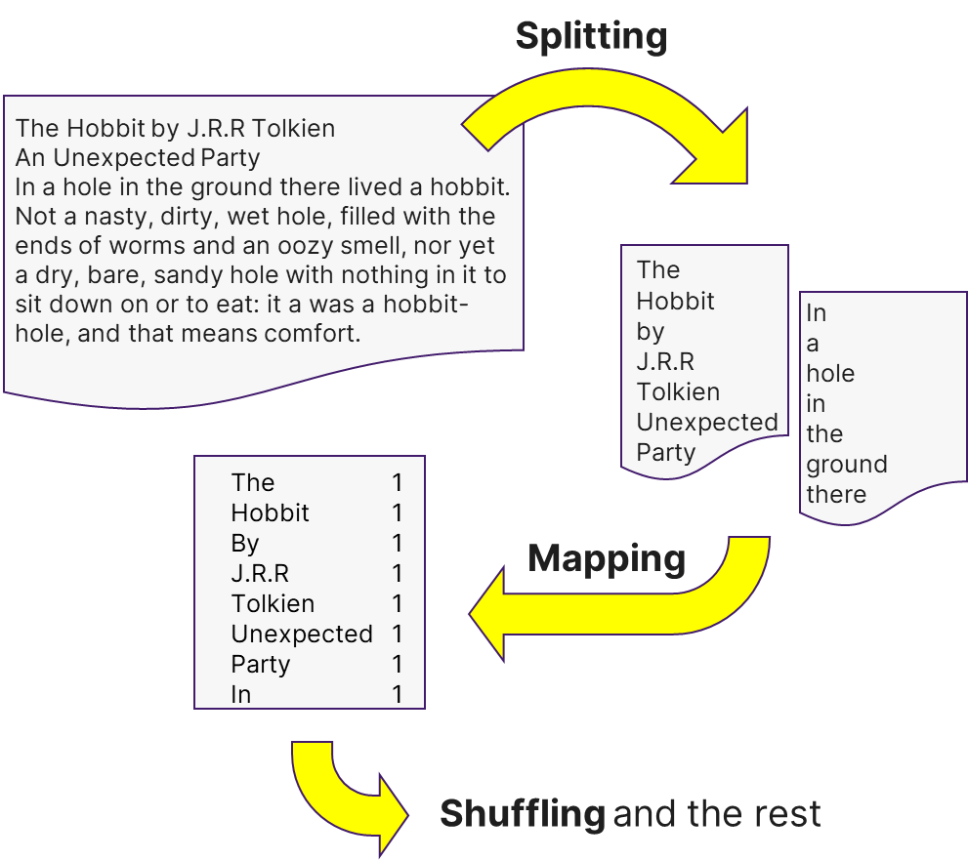

Activity

Research answers to the following questions

Hadoop uses 3 different types of nodes in the cluster to implement HDFS.
Tick which node types are used just for HDFS:
 | ClientNode
Yes | DataNode
YEs | NameNode
 | NodeManager
 | ResourceManager
Yes | SecondaryNameNode

Most nodes in the Hadoop cluster will be used for storing data blocks and processing them.
What two node types are they implementing?
 | ClientNode
Yes | DataNode
 | NameNode
Yes | NodeManager
 | ResourceManager
 | SecondaryNameNode

Jobs are submitted to a Hadoop cluster using the ClientNode.
What node is accepting the job for resourcing and scheduling?
 | ClientNode
 | DataNode
 | NameNode
 | NodeManager
Yes | ResourceManager
 | ApplicationManager

Which one of the DataNodes in the cluster will process a distributed block of data?
Whichever DataNodes stores the data blocks, with NameNode keeping track of the data blocks to direct client requests to the appropriate DataNodes for processing.
- If the node fails to process the block what happens?
If a DataNode fails while processing a block, Hadoop detects the failure through missed heartbeats, reschedules the task on another node that contains a replica of the data block, and re-replicates the data to maintain fault tolerance.

This is an exercise that can demonstrate that the results of word counting can be used in many ways. There are lots of different projects on other topics like sport but in recent years the ‘Lord of the Rings’ stories by J. R. R. Tolkien have been enjoyed and explored in many ways with film, games, and data analysis!
- Use an internet search engine to search for ‘LOTR word count analysis’

- Check how extensive the search results are by the number of pages returned

A word frequency study visualises how often key terms appear throughout the books to identify major themes, locations, and narrative focus.
- Look at 3 different web site results that look interesting to you and note what they are analysing
A character dialogue analysis counts how many words each character speaks in the film adaptations to compare prominence and screen presence.

YARN

Resourcing and scheduling Hadoop jobs

YARN (Yet Another Resource Negotiator) is the default resource management framework in Hadoop, enabling efficient job scheduling and execution. Kubernetes (K8s) is used instead in cloud-native environments.

ResourceManager is the central authority responsible for managing computing resources and scheduling jobs across the Hadoop cluster.

ResourceManager runs as a master daemon on a single node and coordinates resource allocation.

Tasks delegated to NodeManagers, which manage resources on individual worker nodes where data blocks are stored.

NodeManagers report resource availability to the ResourceManager, ensuring efficient scheduling.

ApplicationMaster (AM) is responsible for job execution and dynamically requests resources from the ResourceManager.

YARN uses data locality ensuring that jobs are scheduled on the nodes where the required data is stored, reducing data transfer overheads like lag.

Resource requests consider CPU and memory constraints, ensuring balanced resource distribution across the cluster.

YARN Federation can scale clusters beyond single ResourceManager limits, allowing massive Hadoop deployments across data centres

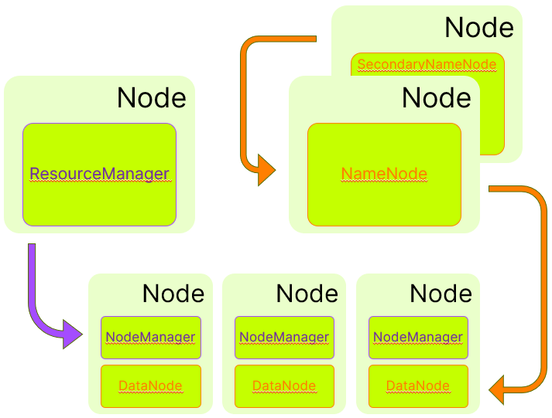

Hadoop operations

Usual steps to process data with Hadoop MapReduce

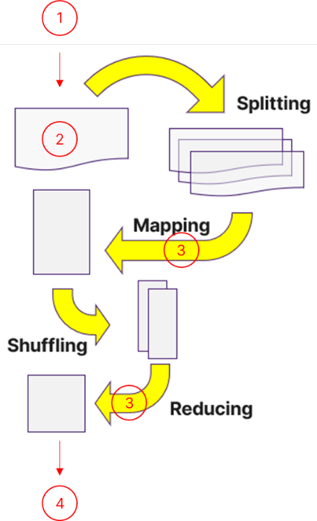
- Prepare the environment

- Ensure Hadoop is installed and configured
- Verify that HDFS and other services are running
- Prepare input data and Java or Python code for map and reduce functions

- Copy data to HDFS

- Use Hadoop command-line interface (CLI) to transfer data from local to HDFS

- Run the MapReduce job

- Submit Hadoop job to run MapReduce functions, specifying input, output, and functions
- Hadoop does the rest
- The framework implements functionality like splitting, shuffling, and sorting as standard built

- Retrieve the results

- Copy the output from HDFS back to the local filesystem

Starting a Hadoop cluster

- With Hadoop is installed there are steps to complete to make it run
- Some Bash scripts are also available to start and stop the cluster services
- NB: Our labs assume a test cluster of only one node
Reference: https://hadoop.apache.org/docs/stable/hadoop-project-dist/hadoop-common/SingleCluster.html#Execution

Activity

Using the reference provided answer these questions:

What command is used to make a portion on the Linux file system HDFS?

fdisk
Which shell script is used to start the HDFS service on a node?

start-dfs.sh
Which shell script is used to start the YARN service on a node?

start-yarn.sh
Which shell script is used to stop the HDFS service on a node?

stop-dfs.sh
Find the Hadoop shell script ‘stop-all.sh’ and note what it does?

- Is there a similar script to start?

Hadoop commands

Basic Commands to use with Hadoop clusters

- There are two basic commands with many options to learn about
- File system operations can be done using either ‘hadoop fs’ or ‘hdfs dfs’ commands
- The ‘hadoop’ and ‘hdfs’ commands have lots of other options for cluster and file system management and other functions as well

References:

Command | Reference
hadoop | https://apache.github.io/hadoop/hadoop-project-dist/hadoop-common/CommandsManual.html
hadoop fs | https://hadoop.apache.org/docs/stable/hadoop-project-dist/hadoop-common/FileSystemShell.html
hdfs | https://hadoop.apache.org/docs/r3.4.1/hadoop-project-dist/hadoop-hdfs/HDFSCommands.html#dfs
hdfs dfs | https://hadoop.apache.org/docs/stable/hadoop-project-dist/hadoop-hdfs/HDFSCommands.html#dfs

‘hadoop’ command
Commands that begin ‘hadoop fs’ provide a more abstract interface for interacting with various file systems like S3 or local file systems
The are other options in the ‘hadoop’ command that are not for the file system. These commands do lots of other things
Tasks include:
- Focus on data processing and job execution
- Interact with MapReduce, YARN for job scheduling and resource allocation
- Run MapReduce jobs and manage YARN components

‘hdfs’ command
Command that begin ‘hdfs dfs’ are primarily used for HDFS operations like managing files and directories in the distributed file system
Tasks include:
- Manage data storage, retrieval, and file system operations
- Copy files to/from Linux or view HDFS directories and files
- Check distributed file system health and handle administrative tasks

Activity

What do these commands do?

hdfs dfs -ls /

lists the files/directories in the HDFS root directory (/).
hdfs dfs -lsr /

recursively lists all files/directories under HDFS root
hdfs dfs -mkdir /wordcount
creates an HDFS directory called /wordcount.
hdfs dfs -cp /data/* /archive
copies all files from HDFS /data into HDFS /archive.
hadoop fs -put $HOME/data/*.csv /sales_reporting

uploads local CSV files into HDFS directory /sales_reporting.
hadoop fs -get /wordcount/output/* . [second argument is a dot]

downloads HDFS output files into the current local directory (.).
hdfs balancer

runs the HDFS balancer to redistribute blocks more evenly across DataNodes.
hdfs dfsadmin -report

shows an HDFS cluster report (capacity, used/free space, DataNodes status).
hdfs fsck / -delete
.
runs HDFS filesystem check from root and deletes corrupt/bad files/blocks it finds (dangerous).
hadoop distcp /src/ /dst/

uses distributed copy to copy data in parallel (often between clusters or large HDFS-to-HDFS copies).
find / -name *hadoop*streaming*.jar 2> null:

searches the local filesystem for Hadoop streaming JARs; 2> redirects errors, but it should usually be 2>/dev/null (not null).

Answer the following questions based on the command shown below:

hadoop jar /usr/local/hadoop-3.3.1/share/hadoop/tools/lib/hadoop-streaming-3.3.1.jar \
-files mapper.py,reducer.py \
-mapper mapper.py \
-reducer reducer.py \
-input /data_source/data.txt \
-output /wordcount/output/
What is the ‘hadoop jar’ command used for?
hadoop jar is used to execute a Hadoop job packaged inside a JAR file.
In this case, it runs the Hadoop Streaming JAR, which allows you to use non-Java programs (like Python) as MapReduce mappers and reducers.

What are the names of the files which contain the Python code for phases 2 and 4 of the MapReduce paradigm?

MapReduce phases:
- Phase 2 → Map phase
- Phase 4 → Reduce phase
The Python files are:
- mapper.py
- reducer.py

In the command shown what is the path where the hadoop command will look for your Python code?
-files mapper.py,reducer.py
It is important to be clear which file system the data was on before that command was run –

Was it on your personal computer, the Linux VM, or the HDFS file system also on the Linux VM when it has the test cluster running?
Since it does not include file://, this path refers to:
HDFS (the Hadoop Distributed File System) running on the Linux VM cluster.
Which file system is the /wordcount/ folder on?

-output /wordcount/output/
Which folder must be deleted each time before the same Hadoop job is re-run?

/wordcount/output/

Using
hdfs dfs -rm -r /wordcount/output

End!

